15.10: a) The relevant expressions are
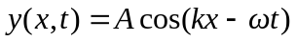
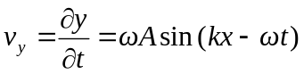
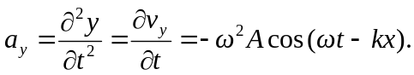

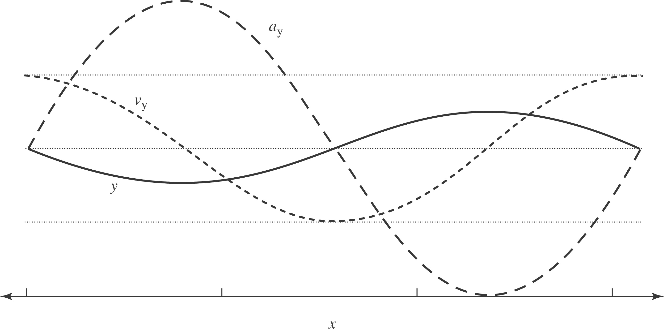

b) (Take A, k and to be positive. At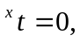 the wave is represented by (19.7(a)); point (i) in the problem corresponds to the origin, and points (ii)-(vii) correspond to the points in the figure labeled 1-7.) (i) 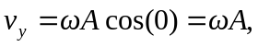 and the particle is moving upward (in the positive y-direction). 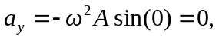 and the particle is instantaneously not accelerating. (ii)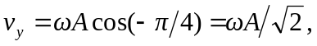 and the particle is moving up. 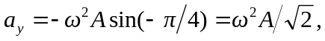 and the particle is speeding up.
(iii) 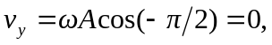 and the particle is instantaneously at rest. 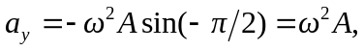 and the particle is speeding up.
(iv) 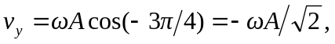 and the particle is moving down. 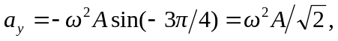 and the particle is slowing down (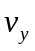 is becoming less negative). (v) 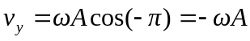 and the particle is moving down. 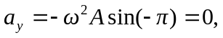 and the particle is instantaneously not accelerating.
(vi) 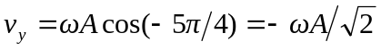 and the particle is moving down. 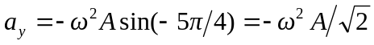 and the particle is speeding up ( and 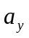have the same sign). (vii) 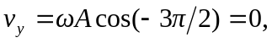 and the particle is instantaneously at rest. 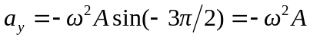 and the particle is speeding up.
(viii) 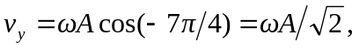 and the particle is moving upward. 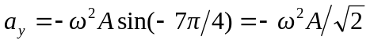 and the particle is slowing down ( and have opposite signs).

